# **Exploratory Data Analysis (EDA) Report**

## **Introduction**

The purpose of this report is to conduct an exploratory data analysis (EDA) on the given dataset Daily Public Transport Passenger Boardings By Ticket Type in order to gain insights into its structure, patterns, and relationships between variables.

## **Dataset Overview**

* ***Dataset Name***: Daily Public Transport Passenger Boardings By Ticket Type
* ***Dataset Description***: This dataset contains daily Public Transport Patronage in types of tickets including MyWay cards and paper tickets. Paper tickets purchased from Ticket Vending Machines are excluded. Patronage for special events are excluded.
* ***Number of Rows***: 1778
* ***Number of Columns***: 3
* ***Date Range***: [2019-07-01,2024-05-12]

## **Data Quality Check**

* Missing Values:No Missing values
* Data Types: Date:Date&Time ,MyWay:INT, Paper Tickets:INT

### **Numerical Variables**

* Summary Statistics:
* MyWay
* Mean:40985.889201
* Std :23275.162569
* Min:0.000000
* Max:88313.000000
* Median:45079.5
* Paper Tickets
* Mean:3744.153543
* Std :2153.562760
* Min:13.000000
* Max:10310.000000
* Median:3374.5
* Distribution:

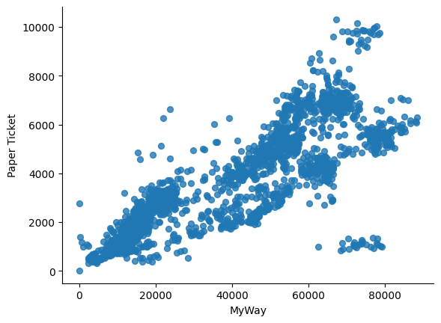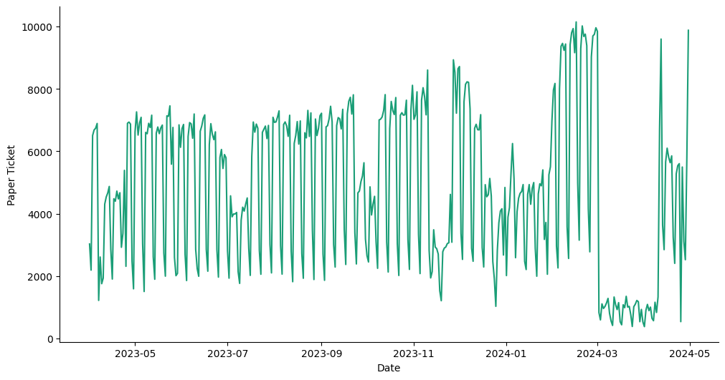

### **Numerical-Numerical Relationships**

* Correlation:Between MyWay and Paper Tickets is 0.681837

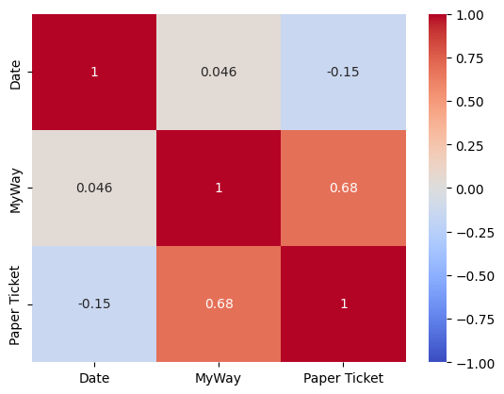

For an year span (1st Apr 2023 to 30th Apr 2024)

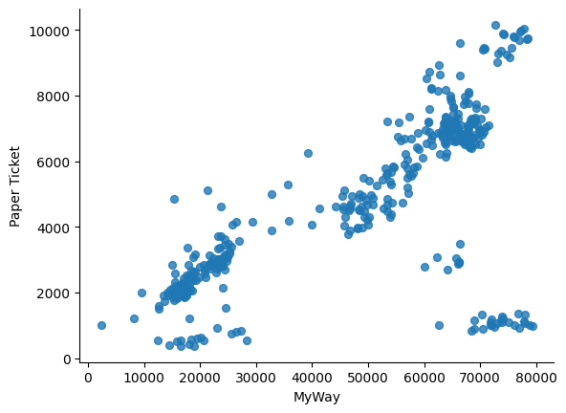

## **Plots and Distributions**

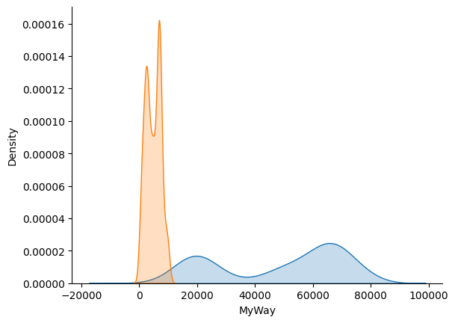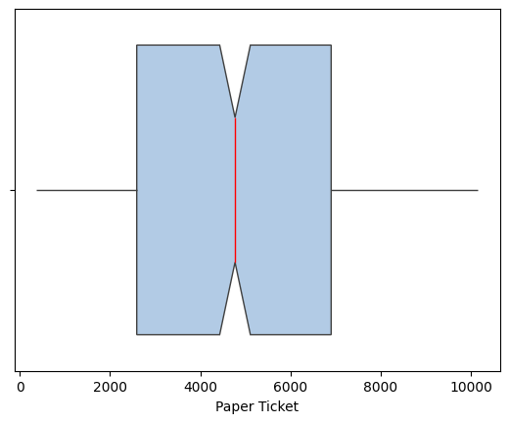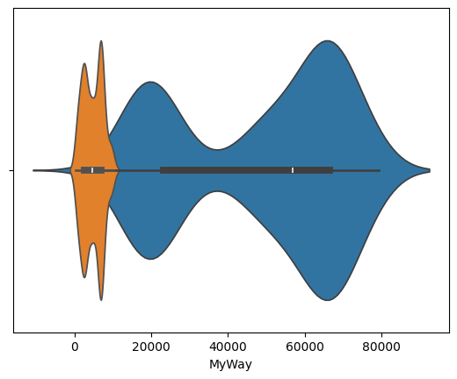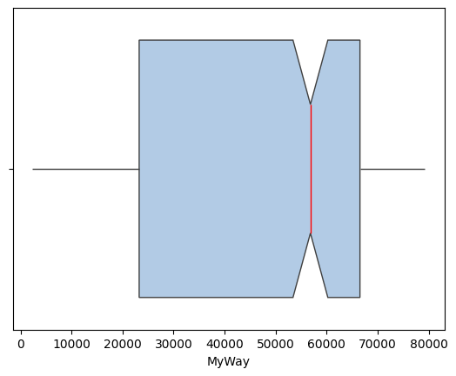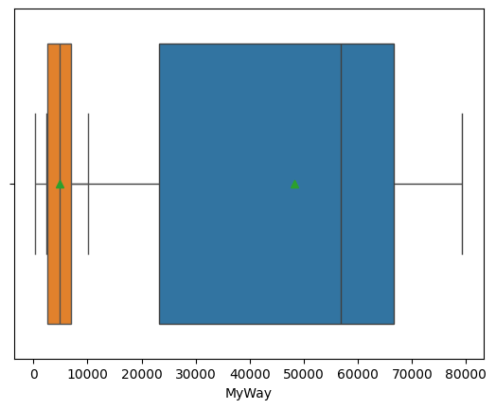

## **Conclusion**

* MyWay and Paper Tickets are strongly correlated.
* No Outliers.